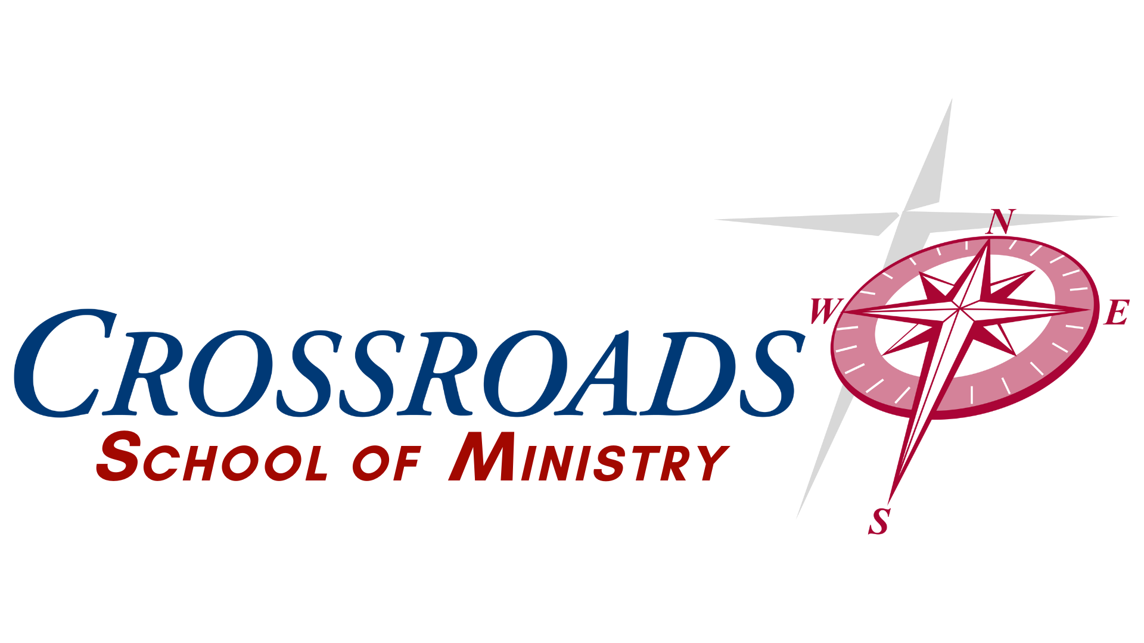
MINISTRY LEADERSHIP INSTITUTE - Course Information
Course Title: 111 Practicum (Church Service)
Credit Hours: 3
Course Delivery Format: Online
Instructor Information
Name: Dr. Jeff Greco
Contact Information: (740) 632-3743 Jeff@come2crossroads.org

Course Description
This course is designed to familiarize the students with actual service in the local church or related ministry in their field.

Course Learning Outcomes
The student will be familiar with the overall function and duties of staff and key volunteers in the local church and church related ministries. Students will complete 40 hours of service to be logged and journaled.

Education Outcomes

Communication, Written, Oral, Interpersonal Teamwork
- Compose written messages, essays, and reports that are clear, logical, professional in tone, and free from grammatical errors.
- Deliver clear oral presentations based on logical arguments and an understanding of rhetoric that are supported by effective visual, auditory, and technical tools.
Information Literacy
- Locate, evaluate, and cite credible information and scholarly sources by using relevant technology and the Bible effectively.
- Apply, credible, scholarly sources and the Bible to support insights and suggestions in oral presentations and written projects and cite sources correctly.
Proverbs 18:13 - To answer before listening, that is folly and shame.
Critical Thinking and Problem Solving
- Apply, analyze, synthesize, and evaluate information to form logical arguments, support insights, and suggestions, and make insightful inferences from data, scholarly resources and most importantly the scriptures.
- Apply critical thinking, creative innovation, and logic to solve problems and contribute to effective community conversations.
- Develop an understanding of both the Bible and the Holy Spirit to allow God’s voice to lead in solving problems and effectively communicating.
Romans 12:2 – Do not conform to the pattern of this world, but be transformed by the renewing of your mind. Then you will be able to test and approve what God’s will is—his good, pleasing and perfect will.
Intercultural Knowledge and Competence
- Students appreciate social and cultural diversity, as measured by the demonstration of a better-than-average ability to discuss and analyze social, cultural, and historical issues, phenomena, and events from a non-evaluative, non-biased, biblical perspective.
- Students begin to view the mission of the church as applicable to all and cultivate a mission that embraces diversity as the gospel does.
Galatians‬ 3‬:28‬ - “There is neither Jew nor Gentile, neither slave nor free, nor is there male and female, for you are all one in Christ Jesus.”‬‬‬‬‬‬‬‬‬‬‬‬‬‬‬‬‬‬

Course Requirement
- All class assignments, papers, and discussions are online.

Course Expectations
- Participation in weekly discussions is required.
- All written assignments must be turned in on time unless previously discussed with professor.

Assessment Types
ASSESSMENT | NUMBER OF ASSIGNMENTS | POINTS
Proposal | 1 | 100
Journal entries | 5 (one for each 8 hour segment) | 500
Self Assessment Paper | 1 | 400
TOTAL | 23 | 1000

Grading Scale
A: 93-100% B: 85-92% C: 77-84% D: 70-76% F: <70%
POINTS | PERCENTAGE | GRADE
930-1000 | 93% - 100% | A
850-929 | 85% - 92% | B
770-849 | 77% - 84% | C
700-769 | 70% - 76% | D
0 – 700 | 0% - 69% | F

Course Resources
Required Texts

The Bible – Any version is acceptable, but NIV, NKJV, ESV or NASB are preferred. For understanding multiple versions can be consulted. Scriptures quoted will be from the NIV (2011) unless otherwise noted. All these versions are available in print or free at BibleGateway.com.

Suggested outside reading
As directed

Course and Academic Policies

Academic Dishonesty
Student integrity and scholastic honesty are an integral part of the CMLI’s scholastic standard, academic quality, and a foundation for our society.

The CMLI will not tolerate the breach of this integrity through cheating, plagiarism, or other forms of academic dishonesty. Faculty and staff will take precautions to prevent academic dishonesty, but it is also the student’s joint responsibility to report known infractions.

Offenses which may warrant expulsion include the following:

- Cheating, plagiarism, or other forms of scholastic dishonesty.
- Furnishing false information to the CMLI with intent to deceive.

Tentative Course Schedule
All assignments and course work in 111 Practicum are self paced, but must be completed prior to completion of program and certificate
Unit | Due Date
Proposal –  Present a proposal for approval detailing the Practicum. It should include the department or role, the supervisor, expected duties and expected time frame of completion. Please include supervisors contact information. | Due Date:  Proposal must be turned in before Practicum can begin.
Journal Entries -  After each 8 hours of Practicum, students should turn in a journal entry. This entry can be in any format (logbook, short paper, video, etc) but should detail progress, describe ministry activity and reflect / comment on ministry effectiveness and possible improvements. | Due Date:  Journal entries are self paced but should be turned in as soon as possible following each 8 hour period completed.
Self Assessment Paper  A 2-3 page paper that summarizes and describes the Practicum experience with concluding comments on student effectiveness, overall ministry effectiveness, and possible improvements. This is a summary of the journal entries, but also a better opportunity to apply details and material from the program to ministry situations. Student can describe where they witnessed previously learned concepts being used or describe where they could have helped effectiveness. | Due Date:  At completion of Practicum hours

