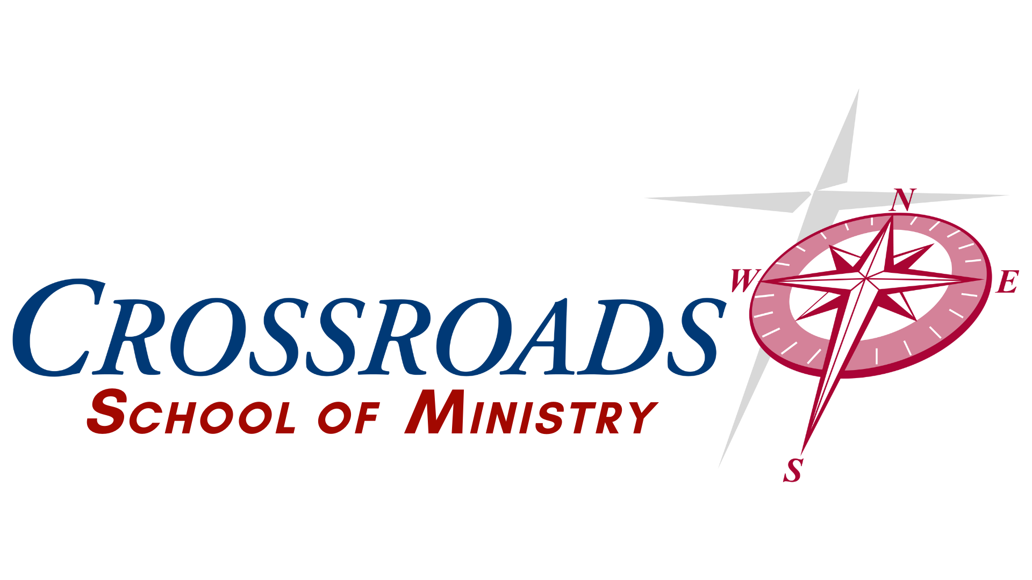
MINISTRY LEADERSHIP INSTITUTE - Course Information
Course Title: 108 Bible 3 – OT History (Gen – Neh)
Credit Hours: 3
Course Delivery Format: Online
Instructor Information
Name: Dr. Jeff Greco
Contact Information: (740) 632-3743 Jeff@come2crossroads.org

Course Description
This course is designed to familiarize the students with the Old Testament Historical books (Genesis – Nehemiah). Survey, basic understanding, construction, and application of this part of the scriptures will be explored and practiced.

Course Learning Outcomes
The student will be familiar with the overall construction of this part of the scriptures and understand concepts and tools to investigate and apply those scriptures to daily life and practical ministry.

Education Outcomes

Communication, Written, Oral, Interpersonal Teamwork
- Compose written messages, essays, and reports that are clear, logical, professional in tone, and free from grammatical errors.
- Deliver clear oral presentations based on logical arguments and an understanding of rhetoric that are supported by effective visual, auditory, and technical tools.
Information Literacy
- Locate, evaluate, and cite credible information and scholarly sources by using relevant technology and the Bible effectively.
- Apply, credible, scholarly sources and the Bible to support insights and suggestions in oral presentations and written projects and cite sources correctly.
Proverbs 18:13 - To answer before listening, that is folly and shame.
Critical Thinking and Problem Solving
- Apply, analyze, synthesize, and evaluate information to form logical arguments, support insights, and suggestions, and make insightful inferences from data, scholarly resources and most importantly the scriptures.
- Apply critical thinking, creative innovation, and logic to solve problems and contribute to effective community conversations.
- Develop an understanding of both the Bible and the Holy Spirit to allow God’s voice to lead in solving problems and effectively communicating.
Romans 12:2 – Do not conform to the pattern of this world, but be transformed by the renewing of your mind. Then you will be able to test and approve what God’s will is—his good, pleasing and perfect will.
Intercultural Knowledge and Competence
- Students appreciate social and cultural diversity, as measured by the demonstration of a better-than-average ability to discuss and analyze social, cultural, and historical issues, phenomena, and events from a non-evaluative, non-biased, biblical perspective.
- Students begin to view the mission of the church as applicable to all and cultivate a mission that embraces diversity as the gospel does.
Galatians‬ 3‬:28‬ - “There is neither Jew nor Gentile, neither slave nor free, nor is there male and female, for you are all one in Christ Jesus.”‬‬‬‬‬‬‬‬‬‬‬‬‬‬

Course Requirement
- All class assignments, papers, and discussions are online.

Course Expectations
- Participation in weekly discussions is required.
- All written assignments must be turned in on time unless previously discussed with professor.

Assessment Types
ASSESSMENT | NUMBER OF ASSIGNMENTS | POINTS
Discussion/Responses | 15(1 post, 2 responses/week) | 300 (60/week)
Assignment | 3 | 300
Paper | 2 | 400
TOTAL | 23 | 1000

Grading Scale
A: 93-100% B: 85-92% C: 77-84% D: 70-76% F: <70%
POINTS | PERCENTAGE | GRADE
930-1000 | 93% - 100% | A
850-929 | 85% - 92% | B
770-849 | 77% - 84% | C
700-769 | 70% - 76% | D
0 – 700 | 0% - 69% | F

Course Resources
Required Texts

The Bible – Any version is acceptable, but NIV, NKJV, ESV or NASB are preferred. For understanding multiple versions can be consulted. Scriptures quoted will be from the NIV (2011) unless otherwise noted. All these versions are available in print or free at BibleGateway.com.

The Prophetic Imagination – Walter Brueggemann
The Bible Jesus Read – Philip Yancey (will also be used in 109)

Suggested outside reading
As directed

Course and Academic Policies

Academic Dishonesty
Student integrity and scholastic honesty are an integral part of the CMLI’s scholastic standard, academic quality, and a foundation for our society.

The CMLI will not tolerate the breach of this integrity through cheating, plagiarism, or other forms of academic dishonesty. Faculty and staff will take precautions to prevent academic dishonesty, but it is also the student’s joint responsibility to report known infractions.

Offenses which may warrant expulsion include the following:

- Cheating, plagiarism, or other forms of scholastic dishonesty.
- Furnishing false information to the CMLI with intent to deceive.

Tentative Course Schedule
Assignments are due at the end of each which is Sunday at 11:59 pm Eastern Standard Time unless otherwise specified.
Unit | Due Date
Week One  Week 1 Discussion Post  Week 1 Responses (2)  Assignment 1  Reading:  Brueggemann Chapter 1  Exodus 1-14 | Due Date:  Week 1 Day 3  Week 1 Day 4, Day 6  Week 1 Day 7
Week Two  Week 2 Discussion Post  Week 2 Responses (2)  Paper 1  Reading:  Yancey Chapter 3  Joshua 1-8 | Due Date:  Week 2 Day 3  Week 2 Day 4, Day 6  Week 2 Day 7
Week Three  Week 3 Discussion Post  Week 3 Responses (2)  Assignment 2  Reading:  Brueggemann Chapters 2-3  2 Samuel 9 | Due Date:  Week 3 Day 3  Week 3 Day 4, Day 6  Week 3 Day 7
Week Four – Connecting OT with NT  Week 4 Discussion Post  Week 4 Responses (2)  Assignment 3  Reading:  Brueggemann Chapter 4-6  1 Kings 17 – 2 Kings 8 | Due Date:  Week 4 Day 3  Week 4 Day 4, Day 6  Week 4 Day 7
Week Five – Practical Ministry with OT  Week 5 Discussion Post  Week 5 Responses (2)  Paper 2  Reading:  Brueggemann Chapter 7 | Due Date:  Week 5 Day 3  Week 5 Day 4, Day 6  Week 5 Day 7

