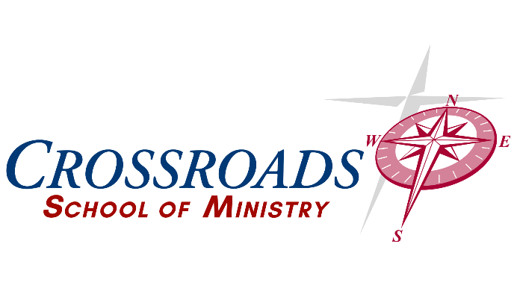

|  |  |
| --- | --- |
| Crossroads School o f Ministry - Course Information | |
| Course Title: 107 Leadership 2 -Practical Church Management  Credit Hours: 3  Course Delivery Format: Online |  |

**Instructor Information**

Name: Dr. Jeff Greco

Contact Information: (740) 632-3743 Jeff@come2crossroads.org

**Course Description**

This course is designed to familiarize students with practical management skills and practices common in the local church. Additionally, students will recognize scriptures that have specific application in the local church regarding management, recruitment, staffing, volunteerism, and leadership in general.

**Course Learning Outcomes**

The student will be familiar with management techniques for the local church and be prepared to apply scripture to the structure, development, and operations in a local church setting.

**Education Outcomes**

**Communication, Written, Oral, Interpersonal Teamwork**

* Compose written messages, essays, and reports that are clear, logical, professional in tone, and free from grammatical errors.
* Deliver clear oral presentations based on logical arguments and an understanding of rhetoric that are supported by effective visual, auditory, and technical tools.

**Information Literacy**

* Locate, evaluate, and cite credible information and scholarly sources by using relevant technology and the Bible effectively.
* Apply, credible, scholarly sources and the Bible to support insights and suggestions in oral presentations and written projects and cite sources correctly.

***Proverbs 18:13 - To answer before listening, that is folly and shame.***

**Critical Thinking and Problem Solving**

* Apply, analyze, synthesize, and evaluate information to form logical arguments, support insights, and suggestions, and make insightful inferences from data, scholarly resources and most importantly the scriptures.
* Apply critical thinking, creative innovation, and logic to solve problems and contribute to effective community conversations.
* Develop an understanding of both the Bible and the the Holy Spirit to allow God’s voice to lead in solving problems and effectively communicating.

***Romans 12:2 – Do not conform to the pattern of this world, but be transformed by the renewing of your mind. Then you will be able to test and approve what God’s will is—his good, pleasing and perfect will.***

**Intercultural Knowledge and Competence**

* Students appreciate social and cultural diversity, as measured by the demonstration of a better-than-average ability to discuss and analyze social, cultural, and historical issues,phenomena, and events from a non-evaluative, non-biased, biblical perspective.
* Studenst begin to view the mission of the church as applicable to all and cultivate a mission that embraces diversity as the gospel does.

***Galatians‬***

**Course Requirement**

* All class assignments, papers, and discussions are online.

**Course Expectations**

* Participation in weekly discussions is required.
* All written assignments must be turned in on time unless previously discussed with professor.
* Assignments do not require formatting. Name, date, and answers are sufficient.
* Papers should be formatted in APA 7. Formatting will not affect grading but is considered best practice.

**Assessment Types**

|  |  |  |
| --- | --- | --- |
| **ASSESSMENT** | **NUMBER OF ASSIGNMENTS** | **POINTS** |
| Discussion/Responses | 15(1 post, 2 responses/week) | 300 (60/week) |
| Assignment | 3 | 300 |
| Paper | 2 | 400 |
|  |  |  |
| **TOTAL** | **23** | **1000** |

**Grading Scale**

A: 93-100% B: 85-92% C: 77-84% D: 70-76% F: <70%

|  |  |  |
| --- | --- | --- |
| **POINTS** | **PERCENTAGE** | **GRADE** |
| 930-1000 | 93% - 100% | A |
| 850-929 | 85% - 92% | B |
| 770-849 | 77% - 84% | C |
| 700-769 | 70% - 76% | D |
| 0 – 700 | 0% - 69% | F |

**Course Resources**

***Required Texts***

**The Bible** – Any version is acceptable, but NIV, NKJV, ESV or NASB are preferred. For understanding multiple versions can be consulted. Scriptures quoted will be from the NIV (2011) unless otherwise noted. All these versions are available in print or free at BibleGateway.com.

***“Talent is Never Enough”,* John Maxwell**

***Suggested outside reading***

As directed

**Course and Academic Policies**

***Academic Dishonesty***

Student integrity and scholastic honesty are an integral part of the CSOM’s scholastic standard, academic quality, and a foundation for our society.

The CSOM will not tolerate the breach of this integrity through cheating, plagiarism, or other forms of academic dishonesty. Faculty and staff will take precautions to prevent academic dishonesty, but it is also the student’s joint responsibility to report known infractions.

Offenses which may warrant expulsion include the following:

1. Cheating, plagiarism, or other forms of scholastic dishonesty.
2. Furnishing false information to the CSOM with intent to deceive.

**Tentative Course Schedule**

**Assignments are due at the end of each which is Sunday at 11:59 pm Eastern Standard Time unless otherwise specified.**

| **Unit** | **Due Date** |
| --- | --- |
| **Week One**  Week 1 Discussion Post  Week 1 Responses (2)  Assignment 1  **Reading:**  Maxwell – Intro, Chapters 1-3 | **Due Date:**  Week 1 Day 3  Week 1 Day 4, Day 6  Week 1 Day 7 |
| **Week Two**  Week 2 Discussion Post  Week 2 Responses (2)  Assignment 2  **Reading:**  Maxwell Chapters 4-6  Isaiah 6:1-8, Revelation 21:1-8, Psalm 93, Psalm 96, Acts 2:37-47, Acts 9 | **Due Date:**  Week 2 Day 3  Week 2 Day 4, Day 6  Week 2 Day 7 |
| **Week Three**  Week 3 Discussion Post  Week 3 Responses (2)  Paper 1  **Reading:**  Maxwell Chapters 7-9  Exodus 18, Joshua 1 | **Due Date:**  Week 3 Day 3  Week 3 Day 4, Day 6  Week 3 Day 7 |
| **Week Four –**  Week 4 Discussion Post  Week 4 Responses (2)  Assignment 3  **Reading:**  Maxwell Chapters 10-11  Matt 4 | **Due Date:**  Week 4 Day 3  Week 4 Day 4, Day 6  Week 4 Day 7 |
| **Week Five –**  Week 5 Discussion Post  Week 5 Responses (2)  Paper 2  **Reading:**  Maxwell Chapters 12-13, Last Words section | **Due Date:**  Week 5 Day 3  Week 5 Day 4, Day 6  Week 5 Day 7 |